Table 1: Alphabetical list of plants used in the study
Scientific name | Common name | Family | Medical utilization | VOSviewer software analysis (Version: 1.6.20) of the literature keywords in web of science with the theme “Scientific Name” of the plant. The color line changes according to the time law, and the more extensive the font, the more significant the influence | Ref.
Acalypha wilkesiana | Copper leaf | Euphorbiaceae | Antimicrobial, anti-inflammatory, wound-healing, neuroprotective properties, skin infections, diabetes, cardiovascular diseases, malaria, anti-fungal infections (Candida albican) | 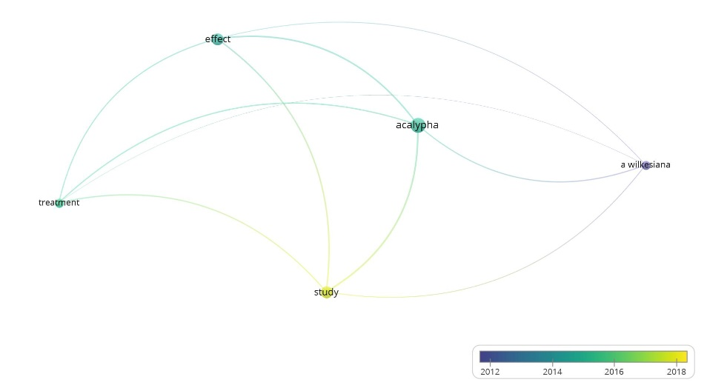 | [42]
Ajuga reptans | Bugle weed | Lamiaceae | Laxative, analgesic, astringent, anti-edematous, anti-hemorrhagic, anti-inflammatory effects, wound-healing, hepatoprotective, and antimicrobial properties, showing activity against Gram-positive bacteria. | 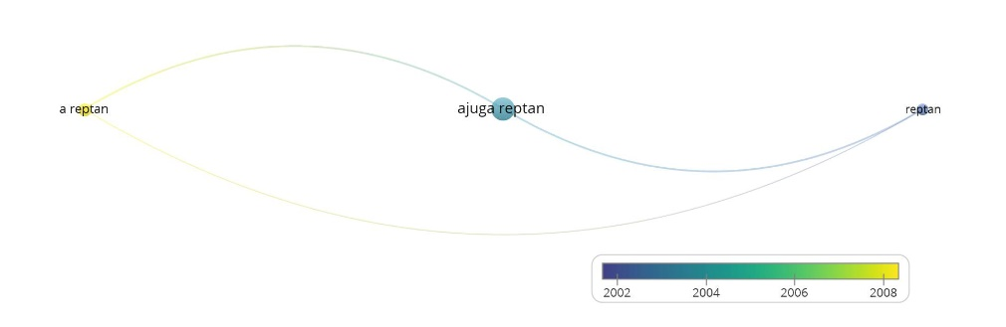 | [43]
Alternanthera dentata | Little ruby | Amaranthaceae | Analgesic, antinociceptive, and anti-inflammatory effects | 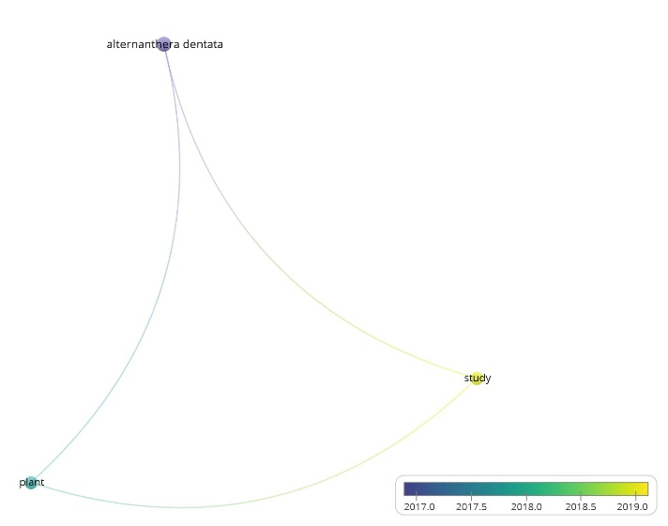 | [44]
Amaranthus gangeticus | Red amaranth/red spinach | Amaranthaceae | Anticancer effects, inhibiting the proliferation of liver (HepG2) and breast (MCF-7) cancer cell lines | 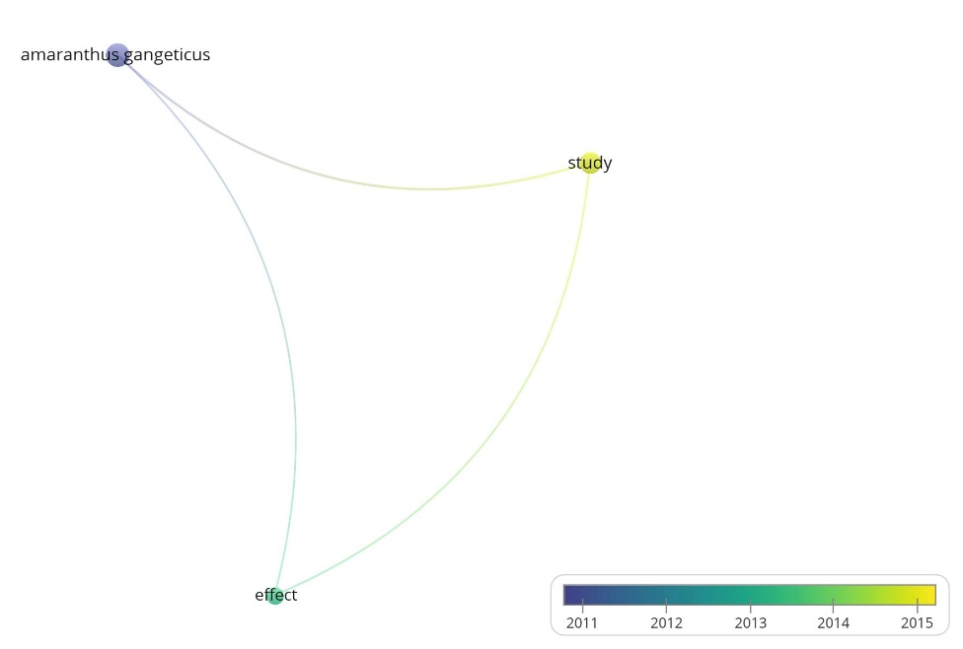 | [45]
Caladium Bombshell | Elephant ear | Araceae | Anti-oxidant effects | No record in Web of Science | [46]
Calathea ornate | Pin Stripe Calathea | Marantaceae | Skin ulcers, swelling, kidney stones, and diabetes | 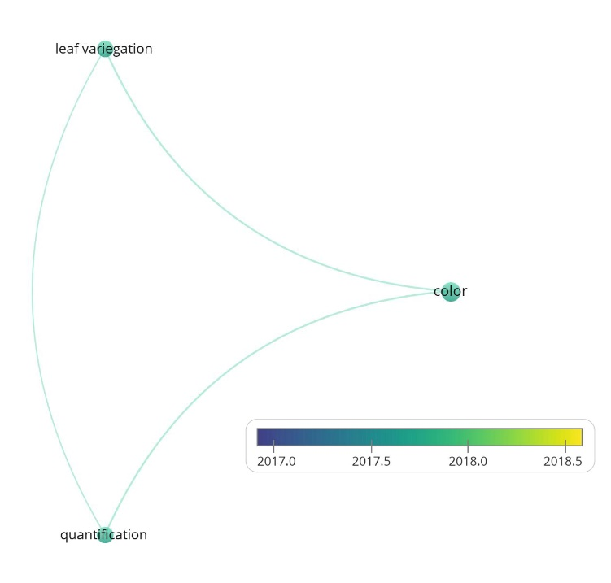 | [47]
Codiaeum variegatum | Fire croton | Euphorbiaceae | Cancer, constipation, diabetes, diarrhea, fever, inflammation, malaria, pain, ulcers, hypercholesterolemia, and external wounds | 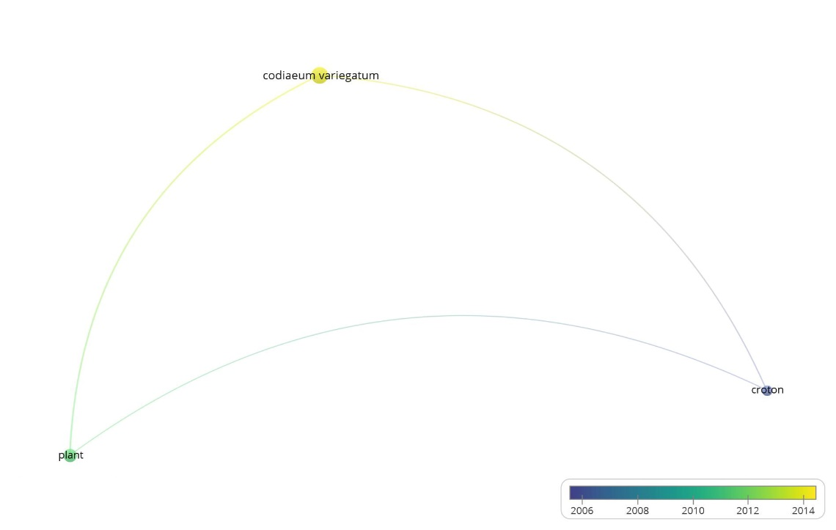 | [48]
Cordyline fruticose | Ti plant | Asparagaceae | Antimicrobial properties, use against cariogenic microorganisms like Streptococcus mutans and Candida albicans | 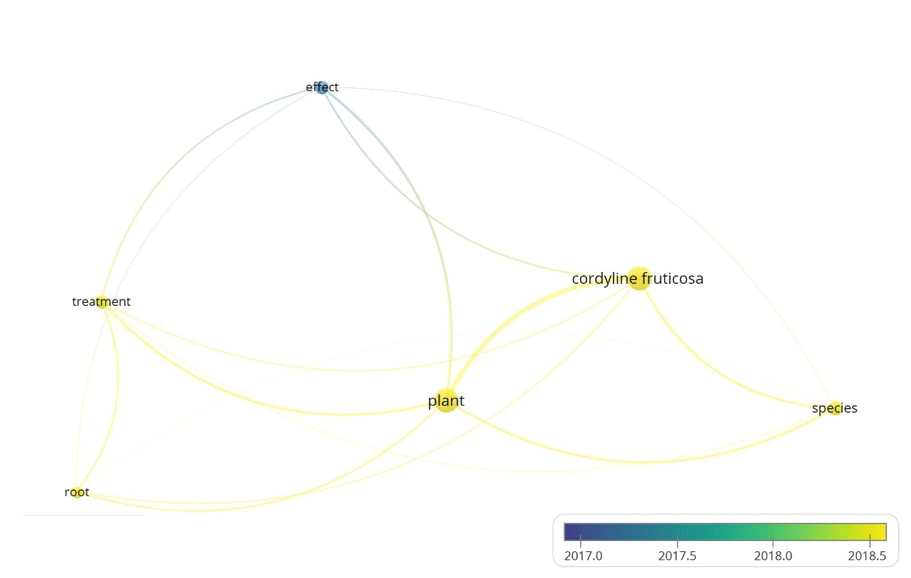 | [49]
Cordyline rubra | Palm lily | Asparagaceae | Sore throat and neck pain. It is also used as a hemostatic | 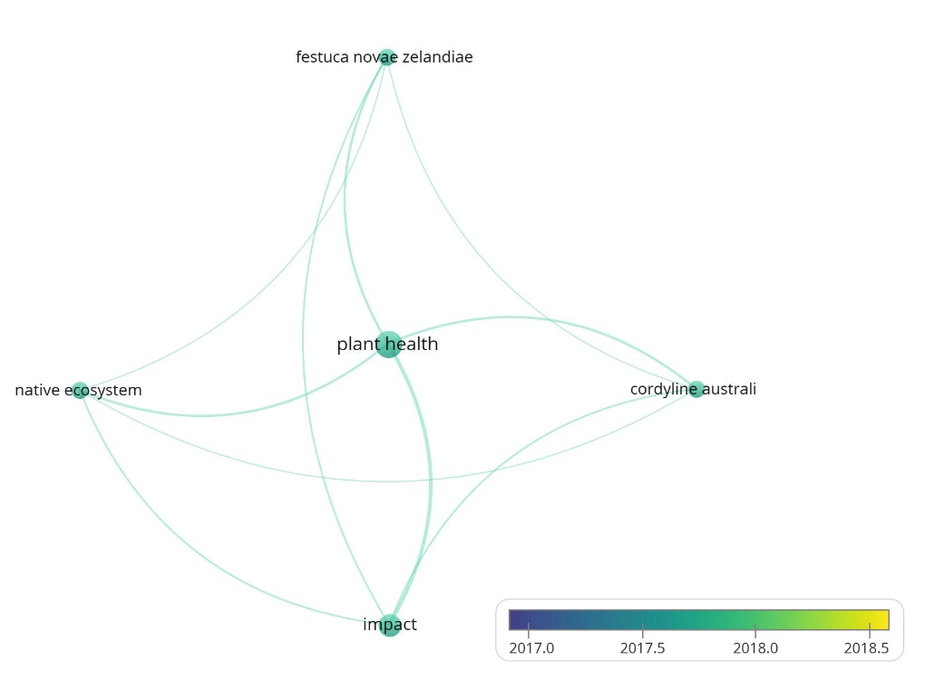 | [50]
Cryptanthus bivittatus | Earth star | Bromeliaceae | Anti-inflammatory and analgesic effects | No record in Web of Science | [51]
Euphorbia cotinifolia | Smoke tree spurge | Euphorbiaceae | Antibacterial, diuretic, anti-Alzheimer's, anti-inflammatory, and immunomodulatory activities, cardiovascular diseases like hypertension, and treating ulcers, cancers, tumors, and warts | 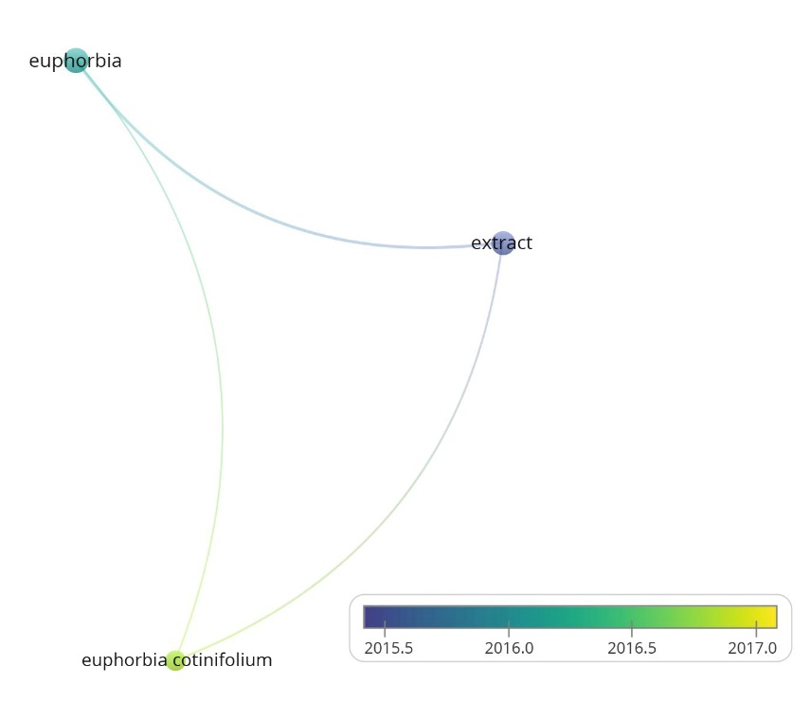 | [52]
Ipomoea batatas | Sweet potato | Convolvulaceae | Immune regulation, improvement of intestinal microbiota, gastric and liver protection, anti-tumor, anti-inflammatory, anti-oxidant, and anti-diabetes effects | 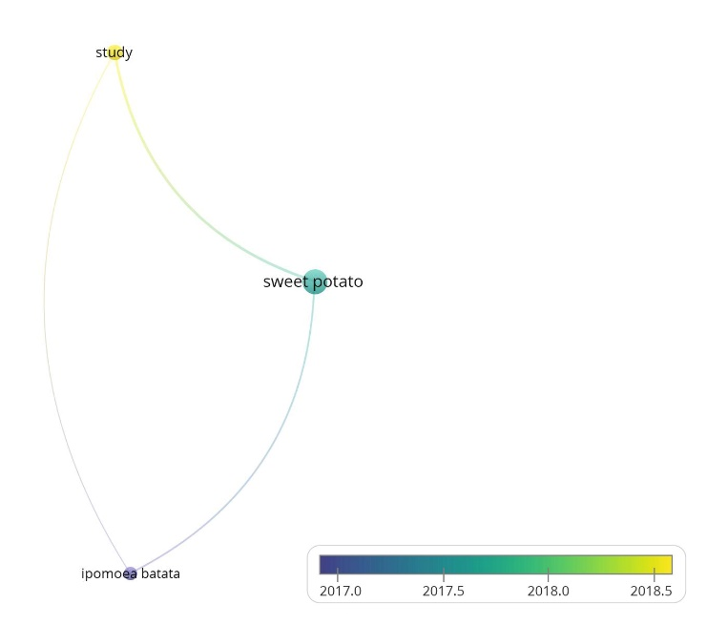 | [53]
Kalanchoe blossfeldiana | Florist kalanchoe | Crassulaceae | Antioxidant, anticancer, antibacterial, antihyperlipidemic, antiaging, and anti-inflammatory properties | 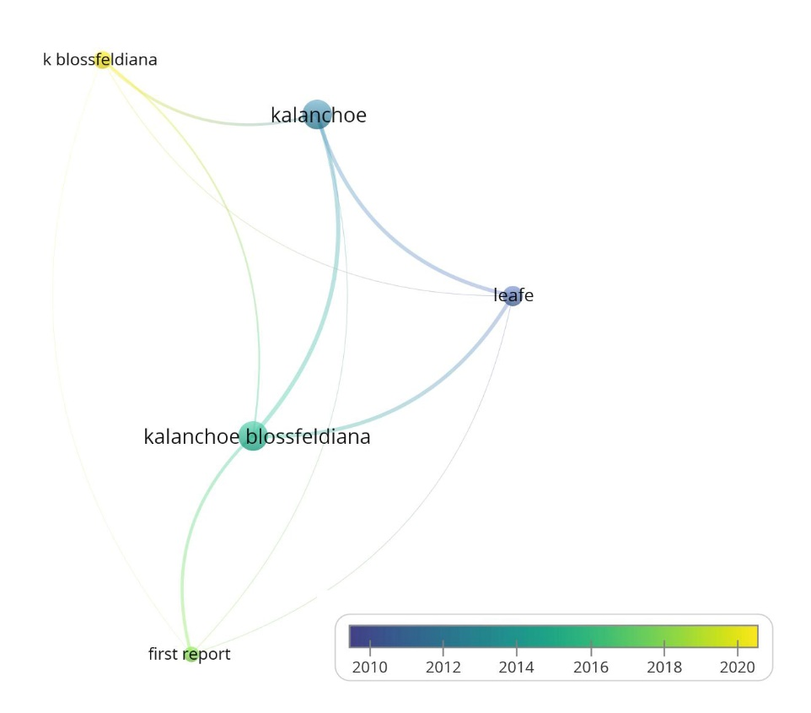 | [54]
Lawsonia inermis | Henna tree | Lythraceae | Ulcers, bronchitis, lumbago, leukoderma, scabies, boils, ophthalmic disorders, hair loss, and jaundice, antibacterial, anticancer, and antioxidant properties | 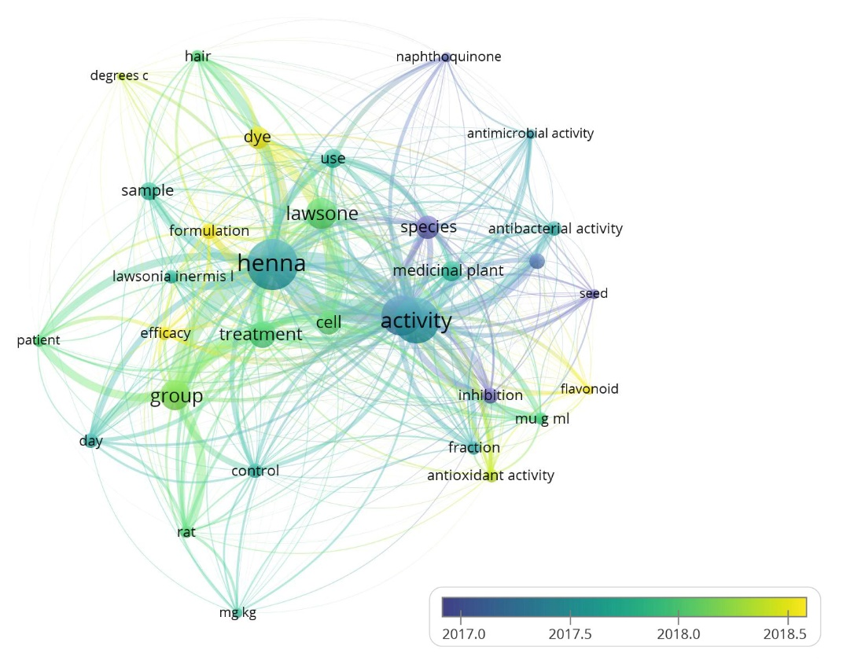 | [55]
Basella alba | Malabar spinach | Basellaceae | Skin disorders, anti-melanogenic, anti-inflammatory, and oxidative stress suppression effects, and diabetes treatment | 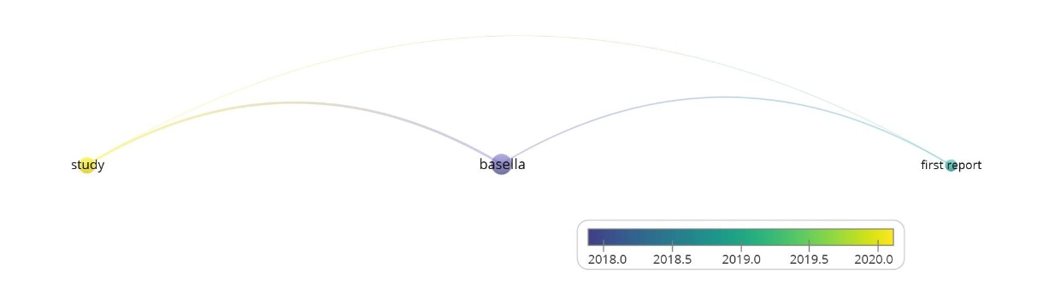 | [56]
Oxalis corniculata | Creeping woodsorrel | Oxalidaceae | Gastrointestinal disorders like diarrhea and dysentery, respiratory diseases, skin diseases, and fever. Antitumor, antimicrobial, antioxidant, anti-inflammatory, and hepatoprotective potentials | 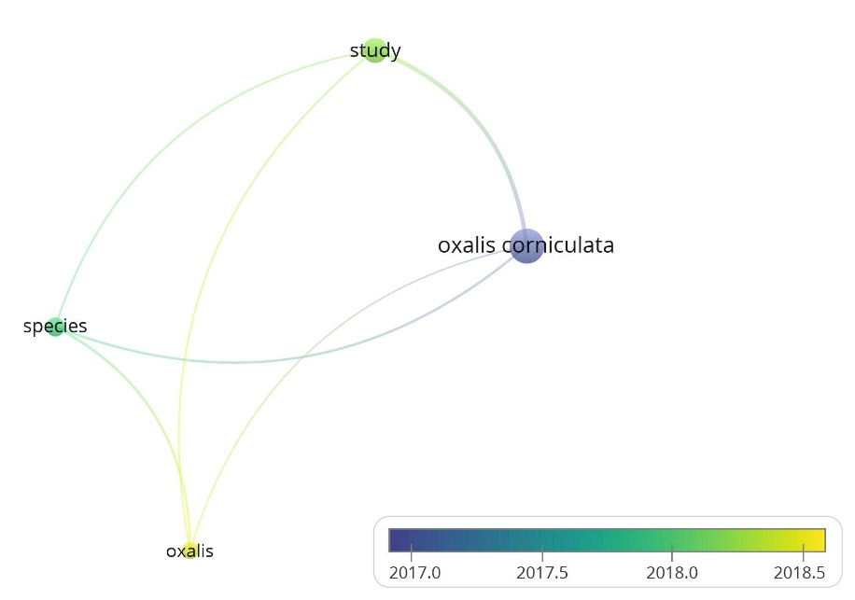 | [57]
Oxalis hedysaroides | Fire fern | Oxalidaceae | Antimicrobial and antioxidant properties | No record in Web of Science | [58]
Oxalis triangularis | False shamrock | Oxalidaceae | Antioxidant properties, broad-spectrum antibacterial activity, effective in acidic conditions | 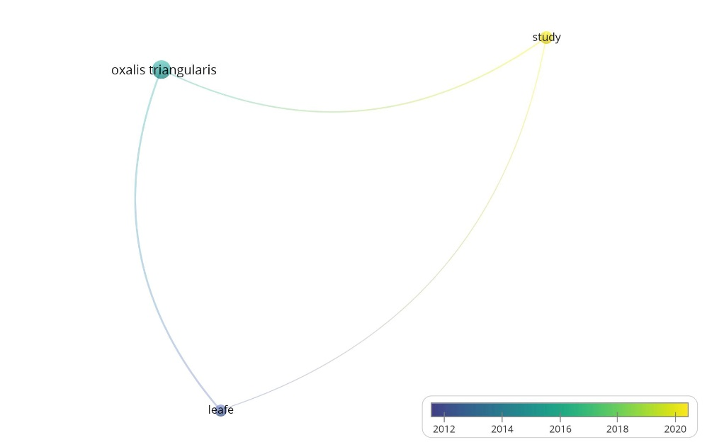 | [59]
Plectranthus scutellarioides | Coleus | Lamiaceae | Abscesses, ulcers, ear and eye infections, abdominal pain, and skin diseases, antibacterial, antioxidant, antifungal, anti-inflammatory, anti-diabetic, and anti-cancer effects | 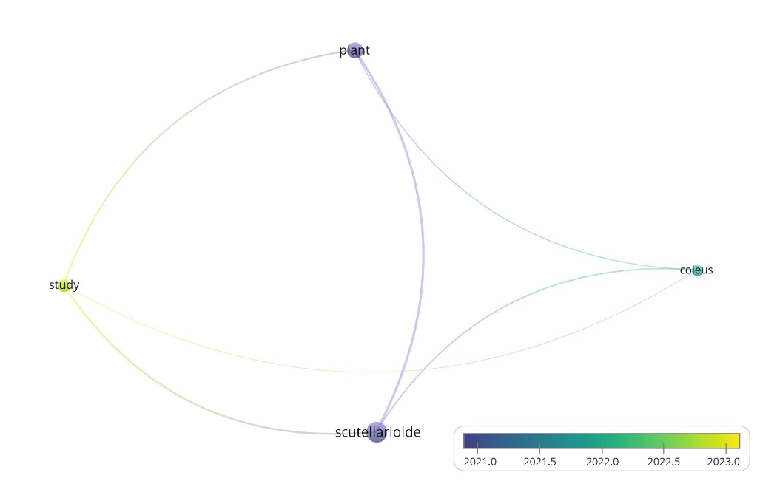 | [60]
Prunus cerasifera | Cherry plum | Rosaceae | Antidiabetic, antimicrobial, anticholinesterase, antioxidant, and anti-obesity activities | 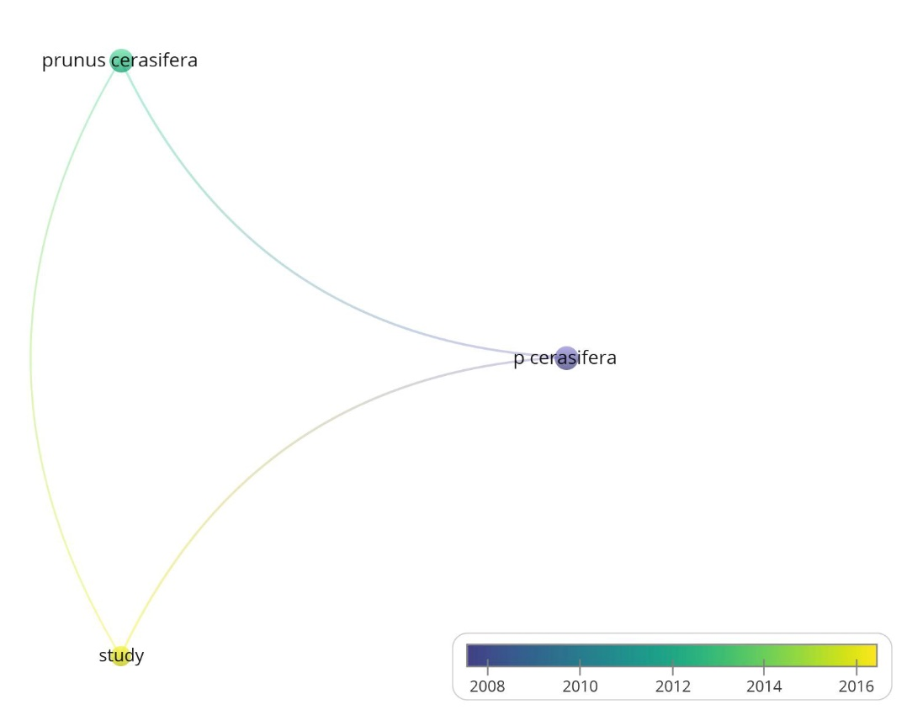 | [61]
Tectona grandis | Teak | Lamiaceae | Diabetes, malaria, anemia, and typhoid fever, as well as pharmacological properties such as antipyretic, analgesic, antibacterial, antioxidant, anti-inflammatory, hypoglycemic, and wound-healing effects | 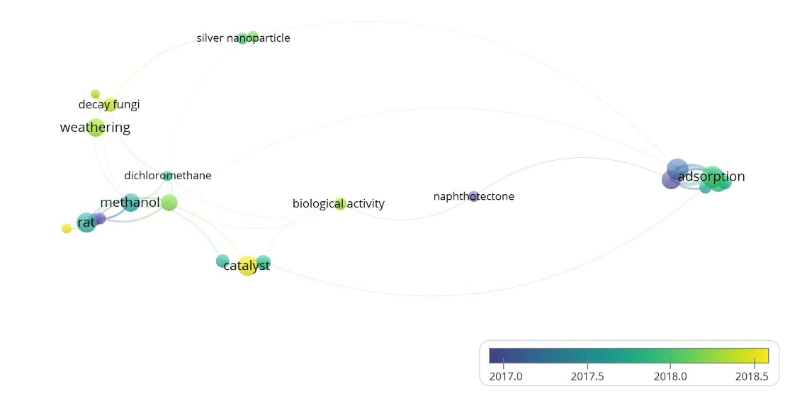 | [62]
Tradescantia pallida | Purple-heart | Commelinaceae | Antidiabetic, antifungal, and cytotoxic properties, antioxidant, antibacterial, and anticancer activities | 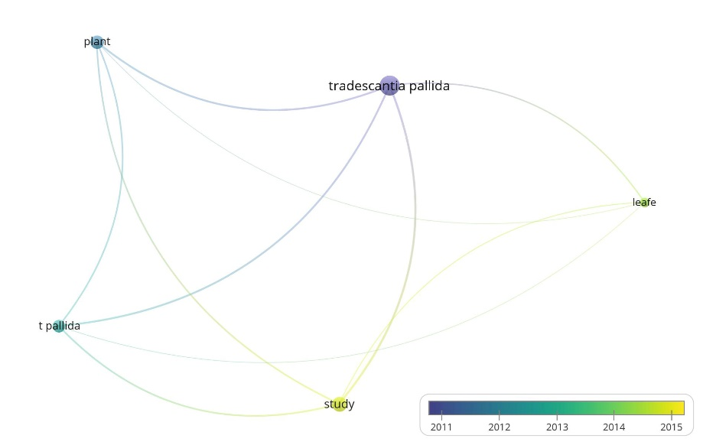 | [63]
Tradescantia spathacea | Boatlily | Commelinaceae | Colds, sore throat, whooping cough, nasal bleeding, and anti-inflammatory, antidiabetic, antiulcer, neuroprotective (specifically for Parkinson's disease), antioxidant, and anticancer properties | 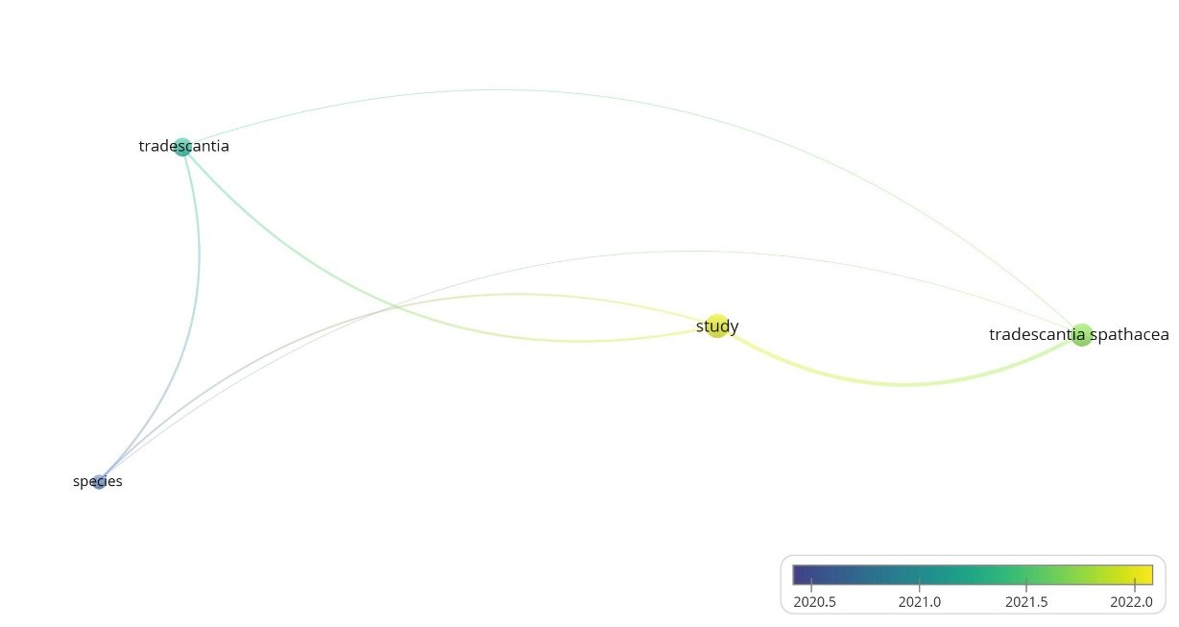 | [64]
Tradescantia zebrina | Inch plant | Commelinaceae | Conjunctivitis, hemorrhoid, and superficial wound dressings, and anti-inflammatory, antinociceptive (pain-relieving), antioxidant, and antibacterial properties | 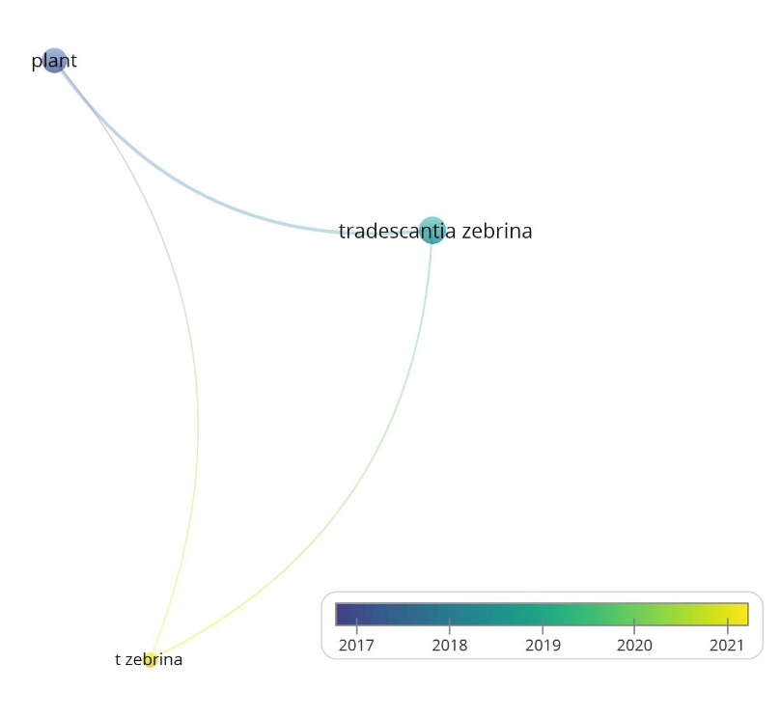 | [65]

Table S2: Bioactive compounds concentration of selected medicinal and ornamental plants
Serial | Name | β-carotene Content (mg/100g) | Lycopene Content (mg/100g) | Flavonoid Content (mg/100g RE) | Anthocyanin Content (mg/100g) | Total phenolic content (mg GAE/100 g)
1 | Acalypha wilkesiana | 4.263±0.223^{m} | 0.292±0.024^{h} | 31.667±1.528^{l} | 34.734±1.336^{j} | 233.333±2.887^{d}
2 | Ajuga reptans | 138.667±1.155^{b} | 2.762±0.538^{h} | 99.333±2.082^{h} | 95.963±2.147e | 105.667±4.041^{h}
3 | Alternanthera dentate | 10.283±0.153^{k} | 10.110±0.538^{g} | 173.333±2.887^{d} | 151.002±3.779^{c} | 178.667±2.309^{f}
4 | Amaranthus gangeticus | 30.655±0.538e | 109.445±8.050ª | 22.516±0.893^{m} | 49.089±1.311^{h} | 106.603±0.759^{h}
5 | Caladium Bombshell | 25.914±0.546^{f} | 15.151±1.321^{g} | nd | 10.420±0.267^{n} | nd
6 | Calathea ornate | 10.889±0.503^{k} | 0.177±0.206^{h} | 29.592±0.921^{l} | 20.707±1.336^{l} | 36.446±1.154^{k}
7 | Codiaeum variegatum | 12.229±0.482^{j} | 0.123±0.027^{h} | 30.170±0.544^{l} | 1.790±0.108º | 33.779±0.680^{k}
8 | Cordyline fruticosa | 17.043±0.357^{h} | 0.540±0.028^{h} | 810.459±1.000ª | 0.267±.0.000º | 106.557±0.517^{h}
9 | Cordyline rubra | 13.676±0.527^{i} | 0.539±0.127^{h} | 502.127±1.536^{b} | 14.740±0.077^{m} | 55.419±1.196^{j}
10 | Cryptanthus bivittatus | 20.486±0.413^{g} | 1.579±0.313^{h} | 3.330±0.308^{r} | 2.039±0.514º | 9.250±0.529^{n}
11 | Euphorbia cotinifolia | 37.126±0.580^{d} | 45.147±4.561e | 73.456±4.095^{j} | 30.904±0.948^{k} | 56.000±1.000^{j}
12 | Ipomoea batatas | 153.213±3.215ª | 72.888±7.848^{c} | 129.231±0.368e | 89.150±1.072^{f} | 5.910±0.046º
13 | Kalanchoe blossfeldiana | 0.753±0.102^{q} | 0.674±0.013^{h} | 13.089±0.574º | 9.752±0.353^{n} | 22.149±0.267^{l}
14 | Lawsonia inermis | 50.182±0.553^{c} | 55.246±11.531^{d} | 31.492±1.041^{l} | 1.607±0.066º | 440.841±0.257^{b}
15 | Malabar spinach | 13.471±0.074^{i} | 24.486±1.281^{f} | 103.637±0.055^{g} | 1.865±0.136º | 91.409±1.208^{i}
16 | Oxalis corniculata | 3.640±0.024^{mn} | 1.008±0.037^{h} | 6.960±0.046^{q} | 1.906±0.373º | 7.773±0.042^{no}
17 | Oxalis hedysaroides | 2.851±0.057^{no} | 1.075±0.037^{h} | 0.970±0.018^{rs} | 1.639±0.344º | 0.973±0.028^{p}
18 | Oxalis triangularis | 2.777±0.265^{no} | 1.175±0.194^{h} | 1.233±0.153^{rs} | 191.667±2.887^{b} | 1.010±0.009^{p}
19 | Plectranthus scutellarioides | 2.310±0.149^{nop} | 0.118±0.019^{h} | 352.178±1.770^{c} | 1.462±0.208º | 250.667±1.155^{c}
20 | Prunus cerasifera | 6.115±0.010^{l} | 21.678±0.221^{f} | 53.667±1.528^{k} | 39.944±0.876^{i} | 12.333±2.517^{m}
21 | Tectona grandis | 1.667±0.294^{opq} | 0.260±0.015^{h} | 107.410±0.611^{f} | 1.826±0.204º | 195.667±5.859e
22 | Tradescantia pallida | 1.045±0.065^{pq} | 0.412±0.017^{h} | 10.556±0.577^{p} | 118.582±2.637^{d} | 150.333±0.577^{g}
23 | Tradescantia spathacea | 1.014±0.036^{pq} | 0.219±0.017^{h} | 95.600±0.178^{i} | 267.182±0.560ª | 250.004±0.459^{c}
24 | Tradescantia zebrina | 3.250±0.173^{mn} | 84.111±7.209^{b} | 16.000±1.000^{n} | 66.617±0.429^{g} | 615.000±2.000ª
Results expressed by average ± standard deviation (n = 3). RE = Rutin equivalent; GAE = Gallic acid equivalent, nd: not detected
a,b means within a column not followed by a standard lowercase letter, are significantly different (P < 0.05).

References
42. Alade, P.I. and O.N. Irobi, Antimicrobial activities of crude leaf extracts of Acalypha wilkesiana. Journal of Ethnopharmacology, 1993. 39(3): p. 171-174 DOI: https://doi.org/10.1016/0378-8741(93)90033-2.
43. Maliuvanchuk, S., et al., Ajuga reptans L. Herb Extracts: Phytochemical Composition and Pharmacological Activity Screening. Plants, 2025. 14(2): p. 219 DOI: https://doi.org/10.3390/plants14020219.
44. Pires, J.M., et al., Phytochemical analysis and investigation of analgesic, anti-inflammatory, and antispasmodic activities of hydroethanolic extracts of Alternanthera dentata, Ocimum carnosum, and Plectranthus barbatus, three species with vernacular names derived from analgesic drugs. Journal of Ethnopharmacology, 2024. 334: p. 118508 DOI: https://doi.org/10.1016/j.jep.2024.118508.
45. Sarker, U. and S. Oba, Polyphenol and flavonoid profiles and radical scavenging activity in leafy vegetable Amaranthus gangeticus. BMC Plant Biology, 2020. 20(1): p. 499 DOI: https://doi.org/10.1186/s12870-020-02700-0.
46. Udo, M., et al., Nutrient composition, mineral and anti-nutrient components of processed wild cocoyam (Caladium bicolor,(Ait) Vent). Current agriculture research journal, 2020. 8(2) DOI: http://dx.doi.org/10.12944/CARJ.8.2.09.
47. Badawy, E.-S.M., E.E. El-Meadawy, and W.H. El-Ezawy, Micropropagation of Calathea medallion an ornamental plant. Plant Archives, 2020. 20(1).
48. Dinakaran, V.S., et al., A systematic review on ethnobotanical and pharmacological aspects of croton plant Codiaeum variegatum (L.). Asian Journal of Research in Chemistry, 2024. 17(3): p. 159-168 DOI: http://dx.doi.org/10.52711/0974-4150.2024.00030.
49. Alphianti, L.T., et al., Identification of bioactive compounds in Cordyline fruticosa (L.) A. Chev. leaf extract and its antimicrobial activity against cariogenic microorganisms. Journal of Advanced Pharmaceutical Technology & Research, 2025. 16(3): p. 156-162 DOI: https://doi.org/10.4103/japtr.japtr_76_25.
50. Yang, M.-H., et al., Rubragenin, chenogenin and wallogenin, steroidal sapogenins from Cordyline rubra. Phytochemistry, 1989. 28(11): p. 3171-3173 DOI: https://doi.org/10.1016/0031-9422(89)80300-0.
51. Cruceru, S., The collection of plants from the Bromeliaceae family of the botanical garden of the university of Craiova. Annals of the University of Craiova-Agriculture Montanology Cadastre Series, 2025. 55(1): p. 43-46 DOI: https://doi.org/10.52846/aamc.v55i1.1660.
52. Jayalakshmi, B., K.A. Raveesha, and K.N. Amruthesh, Isolation and characterization of bioactive compounds from Euphorbia cotinifolia. Future Journal of Pharmaceutical Sciences, 2021. 7(1): p. 9 DOI: https://doi.org/10.1186/s43094-020-00160-9.
53. Bi, H., et al., Recent developments in non-starch Ipomoea batatas (L.) Lam. polysaccharides: extractions and purifications, structural characteristics, pharmacological activities, structure-activity relationships, and applications A review. International Journal of Biological Macromolecules, 2025. 309: p. 142808 DOI: https://doi.org/10.1016/j.ijbiomac.2025.142808.
54. Stefanowicz-Hajduk, J., et al., Antiaging Properties of Kalanchoe blossfeldiana Ethanol Extract—Ex Vivo and In Vitro Studies. Molecules, 2024. 29(23): p. 5548 DOI: https://doi.org/10.3390/molecules29235548.
55. Revathi, S., et al., Lawsonia inermis extract: Antibacterial, anticancer and antioxidant properties. Food systems, 2025. 8(1): p. 73-80 DOI: https://doi.org/10.21323/2618-9771-2025-8-1-73-80.
56. Linsaenkart, P., et al., Anti-Melanogenic Potential of Malabar Spinach (Basella alba) in Human Melanoma Cells with Oxidative Stress Suppression and Anti-Inflammatory Activities. Foods, 2024. 13(18): p. 2943 DOI: https://doi.org/10.3390/foods13182943.
57. Bharti, R., et al., Ethnopharmacology and therapeutic potentials of Oxalis corniculata: an in-depth study. Beni-Suef University Journal of Basic and Applied Sciences, 2024. 13(1): p. 81 DOI: https://doi.org/10.1186/s43088-024-00541-6.
58. Kumaresan, V., et al., In vitro propagation of Oxalis corniculata L, in Micropropagation of Medicinal Plants. 2024, Bentham Science Publishers. p. 318-337.
59. Sharma, S., N.R. Bhuyan, and J.P. Mohanty, A pharmacognostic, phytochemical, and antioxidant potential of Oxalis triangularis. Journal of Applied Pharmaceutical Research, 2024. 12(5): p. 133-145 DOI: https://doi.org/10.69857/joapr.v12i5.701.
60. Kowalczyk, T., et al., Biological Properties of Extracts Obtained from In Vitro Culture of Plectranthus scutellarioides in a Cell Model. International Journal of Molecular Sciences, 2024. 25(2): p. 1043 DOI: https://doi.org/10.3390/ijms25021043.
61. Karakaya, S., et al., Fruitful remedies: analyzing therapeutic potentials in essential and fatty oils, and aqueous extracts from Prunus cerasifera, Malus sylvestris, and Cornus mas using LC-MS and GC-MS. Journal of Faculty of Pharmacy of Ankara University, 2025. 49(2): p. 402-424 DOI: https://doi.org/10.33483/jfpau.1562768.
62. Sanni, O., P. Nkomozepi, and M.S. Islam, Ethyl Acetate Fractions of Tectona Grandis Crude Extract Modulate Glucose Absorption and Uptake as Well as Antihyperglycemic Potential in Fructose–Streptozotocin-Induced Diabetic Rats. International Journal of Molecular Sciences, 2024. 25(1): p. 28 DOI: https://doi.org/10.3390/ijms25010028.
63. Imtiaz, F., et al., Phenolic compounds from Tradescantia pallida ameliorate diabetes by inhibiting enzymatic and non-enzymatic pathways. Journal of Biomolecular Structure and Dynamics, 2023. 41(21): p. 11872-11888 DOI: https://doi.org/10.1080/07391102.2022.2164059.
64. Kushwaha, S., M. Kukshaal, and S.M. Patil, Review on Tradescantia spathacea (medicinal plant). Journal for Research in Applied Sciences and Biotechnology, 2024. 3(6): p. 104-115 DOI: https://doi.org/10.55544/jrasb.3.6.14.
65. Baghalpour, N., et al., Antinociceptive and antiinflammatory studies on Tradescantia zebrina. Pakistan Journal of Botany, 2021. 53(1): p. 357-365 DOI: http://dx.doi.org/10.30848/PJB2021-1(30.

